How to add options to the Word 2013 view

There may come a time where you would like to know the word count of a document or know which column you are in. Below are instructions to add these options on your Word 2013 view.

- First open Microsoft Word
- In the lower left hand side of your screen, right click on the black strip 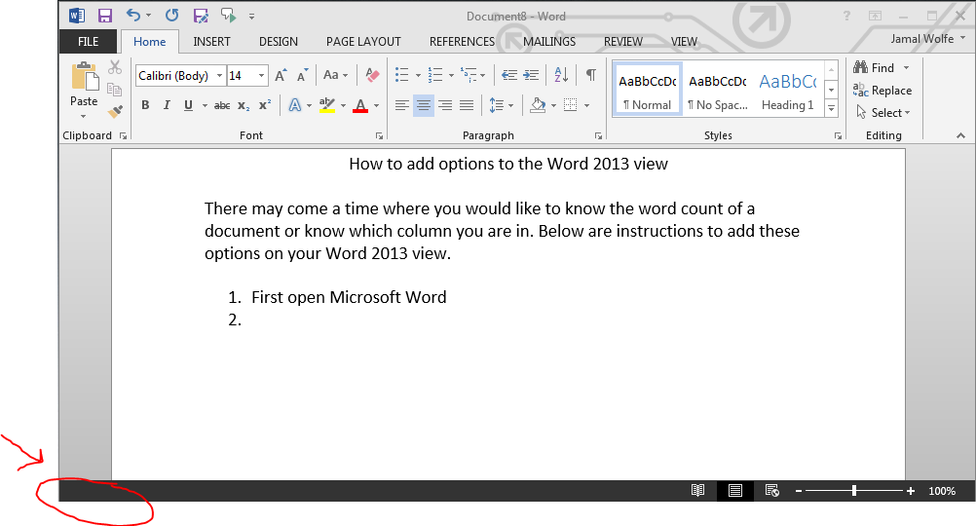
- You will see these options 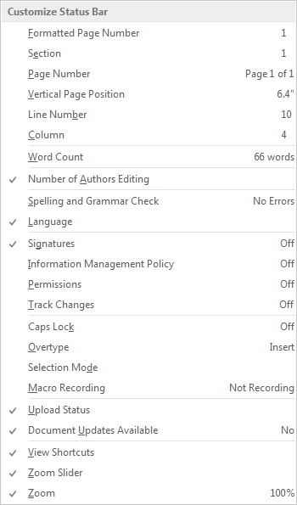
- Select the desired options and then you will see the information in that same black strip 