To change your Microsoft account password

Sign in to your Microsoft account - https://login.microsoftonline.com

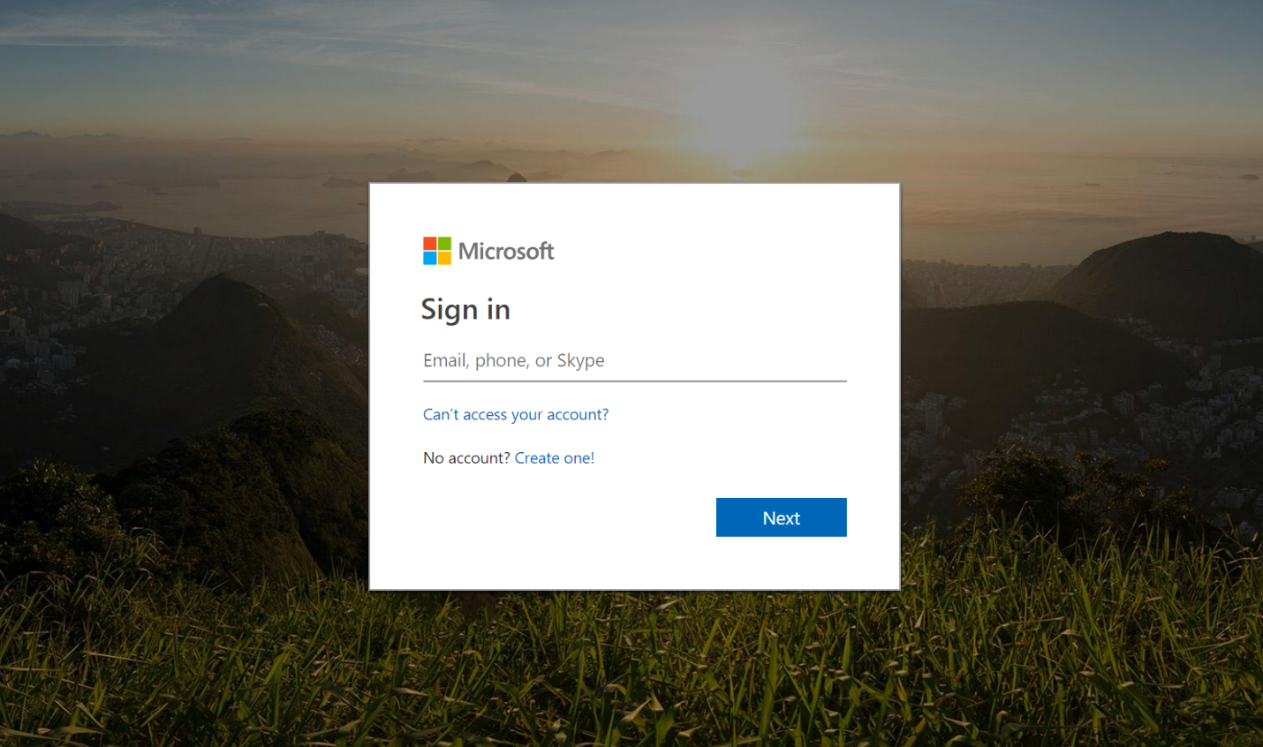

Then select the Gear Icon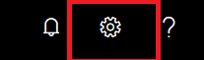, in the top right corner

Select Change Password

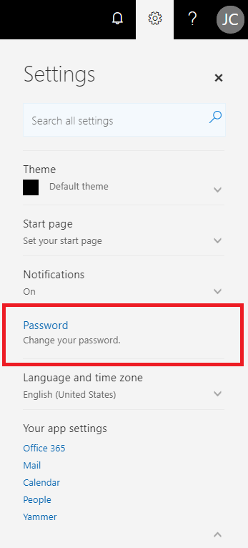

A new window will open
Enter your current password, then password you want and enter the new password again, and click submit
